**Gil Comeau**

Kevin.mchn.io Checkout Review

**January 7th, 2020**

# Overview

The marketing manager at KevDev (https://kevin.mchn.io), a leading widget supplier, has implemented a brand new website and e-commerce store, but she's found that there is a large customer drop off in the checkout process somewhere. She would like you to go through the process and find what you think is the most likely culprit and then mock up what you would do to fix the problem.

# Issues

There are a few substantial issues with the checkout that would lead to high user attrition before making a purchase. The following provides a brief overview of each.

# Addresses

* The shipping address only allows you to select “Canada” as a country but the billing address allows you to select from a plethora of countries.
* There is no option to use the same billing and shipping address.
* See the figures below.

Shipping Address:

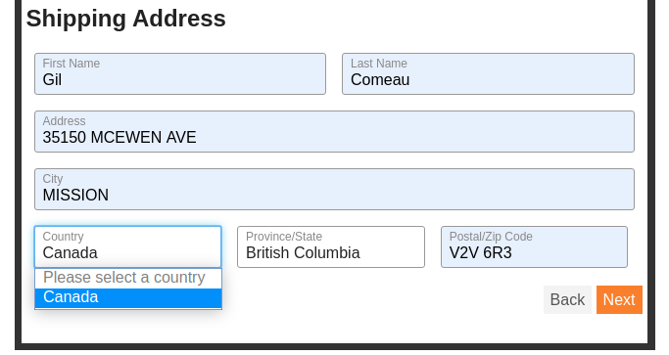

Billing Address:

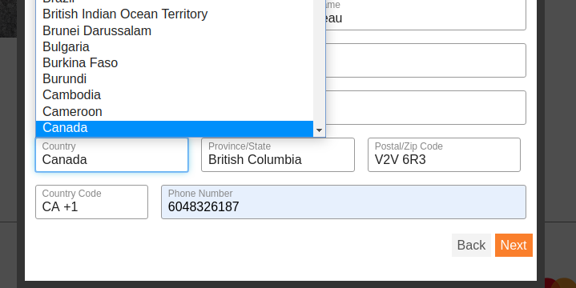

# 

# Return Customers

* There is no way for a return customer to save their demographic information into the form. So each time you make a new transaction you have to fill out the entirety of the form over again.

# Repetitive/Un-necessary Information Collection

* The first and last name field comes up three times when going through the form.
* The phone number is a required field on the billing address field. It’s normally not necessary to require a phone number for delivery.

# Suggested Revisions

The following provides an overview of suggested changes to be made to the checkout on [https://kevin.mchn.io](https://kevin.mchn.io/) that will improve the number of successful customers.

# Addresses

* Add the rest of the countries to the “Country” drop-down list. If you are unable to ship to certain counties, display some form of notification to the user.
* Add a checkbox to use the same shipping and billing address on the shipping address page. This will allow many users to skip a whole page they were previously filling out.

# Return Customers

* Add a checkbox on the first page that allows the user to save the information they are going to into their browser for a period of time. This can simply be saved in local storage. This will allow a repeat customer to skip to entering their credit card details instead of having to fill the form out again…

# 

# 

# Repetitive/Un-necessary Information Collection

* Only ask for first name and last name once, on the first screen of the checkout. If a second name is required for the following two forms, add a checkbox that pops up a hidden input for a separate first and last name on both the billing and shipping address pages.
* Move the phone number field to the first page with the first name, last name, and email address. Remove the required attribute if it’s not a necessity.

# Conclusion

While the current process does work if you’re in Canada, the limitations of the current application prevent the customer from other countries from purchasing products. This is likely the biggest cause of attrition by potential customers. The other items mentioned will also assist in reducing the time the user spends filling out redundant information, which in turn will get more customers through the check out process. The final item it noticed (which is likely out of scope) is that when a transaction is created, an account for the user is created but there is no prompt to ask them for a password. This would be extremely frustrating as a user and should be looked into.